Project Planning Phase

Project Planning Template (Product Backlog, Sprint Planning, Stories, Story points)

Date | 1 November 2026
Team ID
Project Name | EV Market Performance & Insights
Maximum Marks | 8 Marks

Product Backlog, Sprint Schedule, and Estimation (4 Marks)
Use the below template to create product backlog and sprint schedule

Sprint | Functional Requirement (Epic) | User Story Number | User Story / Task | Story Points | Priority | Team Members
Sprint-1 | Market Performance Overview | USN-1 | As a market strategy director, I can view total EV sales, average vehicle price, average range and CO2 saved as KPI cards, so that I can assess overall market performance at a glance. | 3 | High | Team Member 1
Sprint-1 |  | USN-2 | As a market strategy director, I can see annual sales units by vehicle category from 2017 to 2027, so that I can identify high-growth segments. | 5 | High | Team Member 2
Sprint-2 | Customer Satisfaction | USN-3 | As a market strategy director, I can compare top manufacturers by customer review and sales units, so that I can judge manufacturer performance and customer satisfaction. | 3 | Medium | Team Member 3

Sprint | Functional Requirement (Epic) | User Story Number | User Story / Task | Story Points | Priority | Team Members
Sprint-1 | Manufacturer Analysis | USN-4 | As a business intelligence manager, I can compare manufacturers by annual sales and market share, so that I can identify competitive advantages. | 5 | High | Team Member 4
Sprint-1 | Production Analysis | USN-5 | As a business intelligence manager, I can view production output by country and vehicle category, so that I can understand geographic production trends. | 5 | High | Team Member 1
Sprint-2 | Battery Technology Analysis | USN-6 | As a business intelligence manager, I can see which battery technologies lead in annual sales, so that I can advise clients on product positioning. | 2 | Medium | Team Member 2
Sprint-2 | Battery & Range Analysis | USN-7 | As a research analyst, I can compare battery technologies by sales and average battery cycle life, so that I can evaluate technology trends. | 5 | High | Team Member 3
Sprint-2 |  | USN-8 | As a research analyst, I can view the driving range distribution by vehicle category, so that I can assess range improvements. | 5 | Medium | Team Member 4
Sprint-3 | Charging Performance | USN-9 | As a research analyst, I can compare maximum DC charging power with energy efficiency, so that I can study charging performance across categories. | 8 | Medium | Team Member 1
Sprint-2 | Environmental Impact | USN-10 | As a research analyst, I can see CO2 saved per year by market region and drivetrain, so that I can support sustainability and policy recommendations. | 5 | High | Team Member 2

Sprint | Functional Requirement (Epic) | User Story Number | User Story / Task | Story Points | Priority | Team Members
Sprint-3 | Interaction & Filtering | USN-11 | As a dashboard user, I can filter and highlight by vehicle category using the shared legend, so that I can focus on one segment across all charts. | 5 | Medium | Team Member 3
Sprint-1 | Data Management | USN-12 | As a dashboard administrator, I can connect and refresh the EV dataset, so that dashboards always show current data. | 2 | High | Team Member 4

Project Tracker, Velocity & Burndown Chart: (4 Marks)

Sprint | Total Story Points | Duration | Sprint Start Date | Sprint End Date (Planned) | Story Points Completed (as on Planned End Date) | Sprint Release Date (Actual)
Sprint-1 | 20 | 2 Days | 20 Oct 2026 | 21 Oct 2026 | 20 | 21 Oct 2026
Sprint-2 | 20 | 2 Days | 22 Oct 2026 | 23 Oct 2026 | 20 | 23 Oct 2026
Sprint-3 | 13 | 2 Days | 24 Oct 2026 | 25 Oct 2026 | 13 | 25 Oct 2026
Total | 53 | 6 Days | 20 Oct 2026 | 25 Oct 2026 | 53 | 25 Oct 2026

Velocity:
Imagine we have a 10-day sprint duration, and the velocity of the team is 20 (points per sprint). Let’s calculate the team’s average velocity (AV) per iteration unit (story points per day)

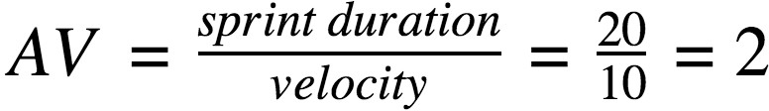

For this project the sprint duration is 2 days, and the team completed 20, 20 and 13 story points in the three sprints. Average velocity per sprint = (20
+ 20 + 13) / 3 = 17.67 story points. Average velocity per day (AV) = velocity / sprint duration = 17.67 / 2 = 8.83 story points per day (53 story points in 6 days).

Burndown Chart:

A burn down chart is a graphical representation of work left to do versus time. It is often used in agile software development methodologies such as Scrum. However, burn down charts can be applied to any project containing measurable progress over time.

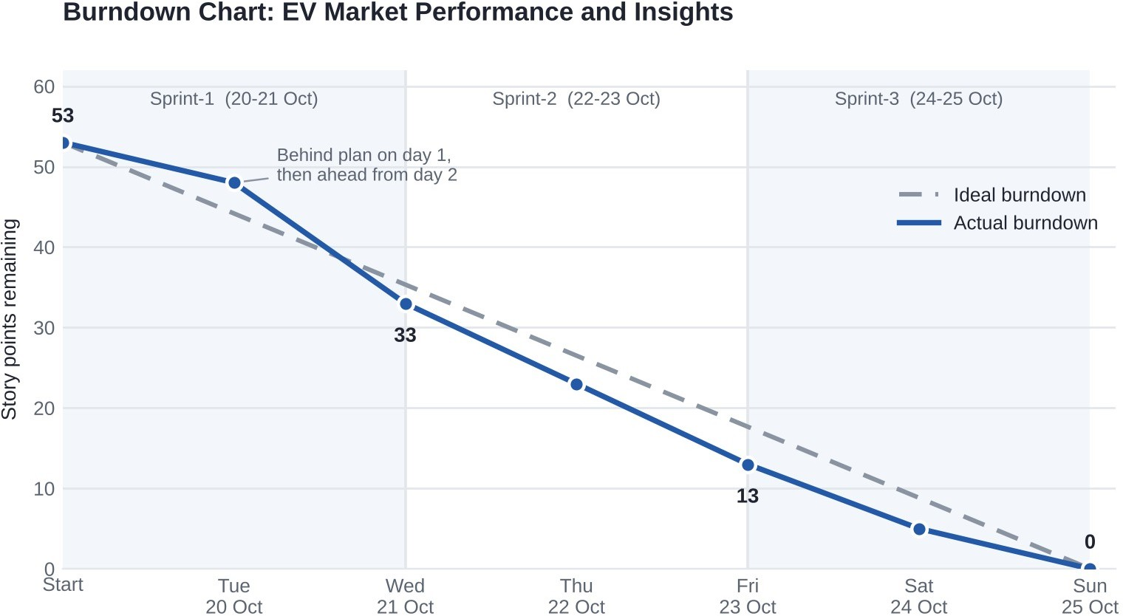
The team started with 53 story points on 20 Oct 2026 and burned them down to 0 by 25 Oct 2026. Day 1 finished slightly behind the ideal line (48 points left against 44), after which the team stayed ahead of plan, and all three sprints closed on their planned end dates (21, 23 and 25 Oct 2026).

https://www.visual-paradigm.com/scrum/scrum-burndown-chart/ https://www.atlassian.com/agile/tutorials/burndown-charts

Reference:
https://www.atlassian.com/agile/project-management https://www.atlassian.com/agile/tutorials/how-to-do-scrum-with-jira-software https://www.atlassian.com/agile/tutorials/epics https://www.atlassian.com/agile/tutorials/sprints https://www.atlassian.com/agile/project-management/estimation https://www.atlassian.com/agile/tutorials/burndown-charts

